|  |  |
| --- | --- |
| **Exercise – Session XX** |  |
| ISYS6898003  Algorithm and Programming |
| Even Semester Year 2024/2025 |

**Name : Muhammad Rizan R**

**Student ID : 2802485965**

**LAB Class Code : LC-81**

**Sertakan screenshot dari potongan kode dan hasil running program yang sudah dibuat.**

1. **Exercise 1**

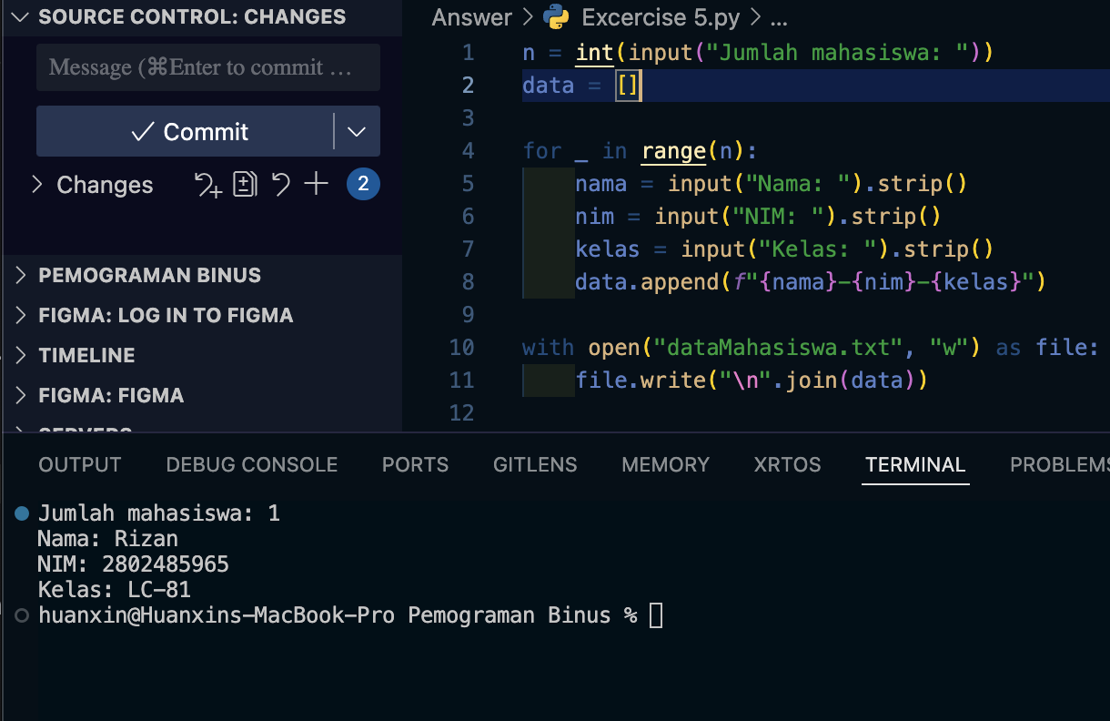

1. **Exercise 2**

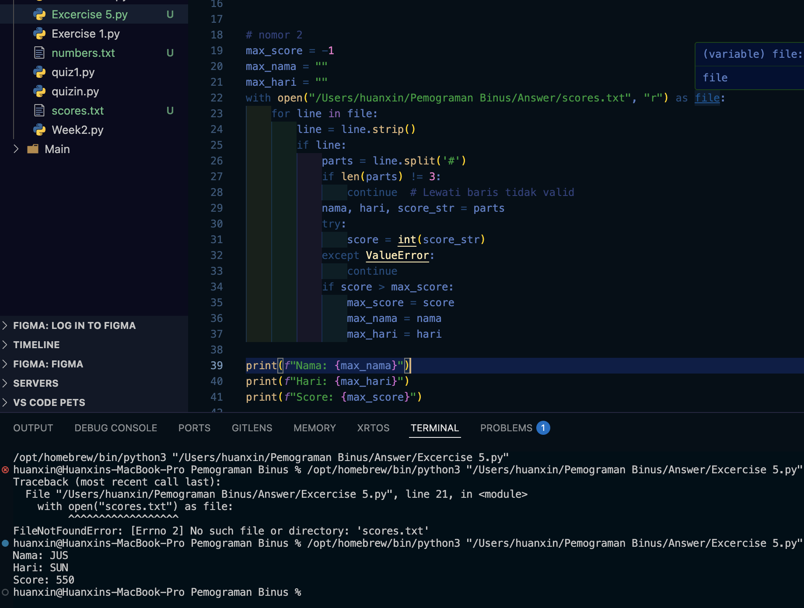

1. **Exercise 3**

